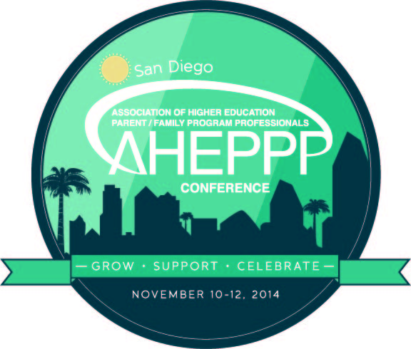

3rd National Conference
November 10 – 12, 2014

Grow ∙ Support ∙ Celebrate

PROGRAM PROPOSAL
Note: Please plan early, especially if you intend to invite your colleagues from other institutions to co-present, which is highly advisable. All proposals must be submitted by 5 p.m. EST, Monday, June 2, 2014. EARLY PROPOSALS WILL RECEIVE PRIORITY CONSIDERATION and notification will be issued on a rolling basis.

Title of Presentation: (10 words or less; the content of the program should be discernible from the title)

Coordinating Presenter:
Name:

Preferred name for printed program:
Title:
Institution:
Address:
City, State, Zip:
E-mail:
Phone:

Additional presenter(s), including name(s), title(s), and institution(s):
Name:
Preferred name for printed program:
Title:
Institution:
Name:
Preferred name for printed program:
Title:
Institution:

Name:
Preferred name for printed program:
Title:
Institution:

Audience: The program committee seeks to provide programs tailored for professionals with a wide range of years of experience. Please indicate the type of audience for which your program is best suited.
New to the field (less than 3 years with parents programming)
Intermediate (4-6 years with parents programming)
Experienced (7+ years with parents programming)
All of the above

Program Format: The program committee seeks to provide presentations that are dynamic and diverse in style. Please indicate what methods will be used for the presentation.

45 Minute Session
Formal presentation with question and answer period (i.e.: PowerPoint, Prezi)
Facilitated discussion; large or small group
Group activity
Other (please describe)
PechaKucha
A PechaKucha is a concise presentation of your ideas, research and thoughts. Share 20 slides, each for 20 seconds with a total presentation time of 6 minutes and 40 seconds. Pechakucha.org.

AHEPPP Talks
AHEPPP Talks are modeled after TED Talks, the videos of “ideas worth spreading” through storytelling (ted.com). Talk for 18 minutes or fewer on a topic related to the AHEPPP conference theme and spirit.

Abstract:
Please include a brief description, which will be printed in the conference program. 75 words maximum.

Purpose of Program

In 500 words or less, please address the following:
- The purpose of the program (why is this important; who is the target audience?)
- Relevance to conference theme
- Presentation method, including how participants will be engaged during the presentation
- Practical applications; how strategies or results can be used by others
- Evidence of a solid foundation for the program’s content, either by citing relevant research or indication of successful outcomes

Thank you for completing a proposal for the 2014 AHEPPP National Conference. Please be sure to email this proposal to dawn.bruner@rochester.edu and Branka.Kristic@hofstra.edu; save a copy for your files.

